**CHAPTER 4**

**SNAPSHOTS**

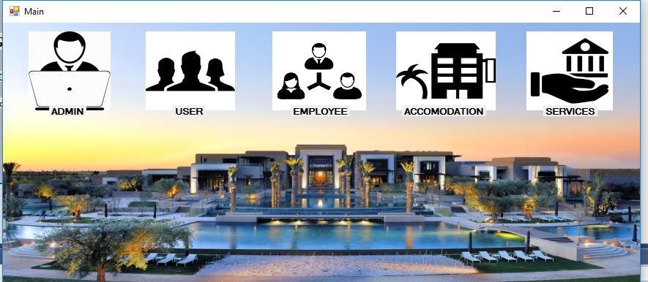

**Fig 4.1: HOME PAGE**

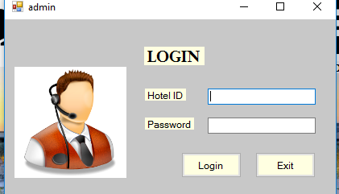

**Fig 4.2: LOGIN PAGE**

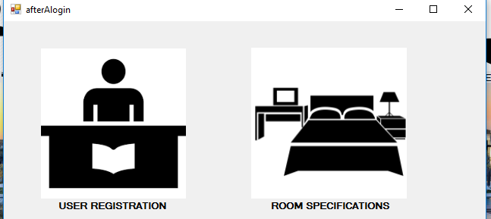

**Fig 4.3: AFTER ADMIN LOGIN**

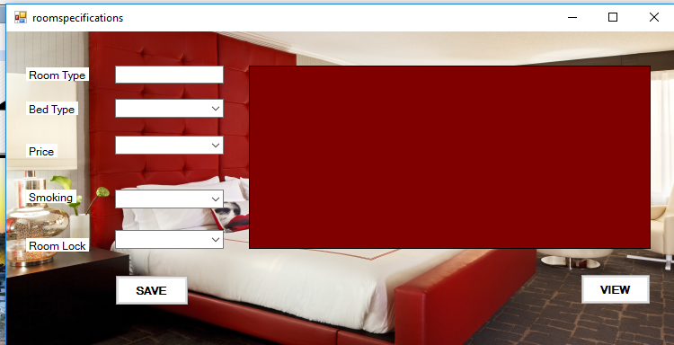

**Fig 4.4: ROOM SPECIFICATION**

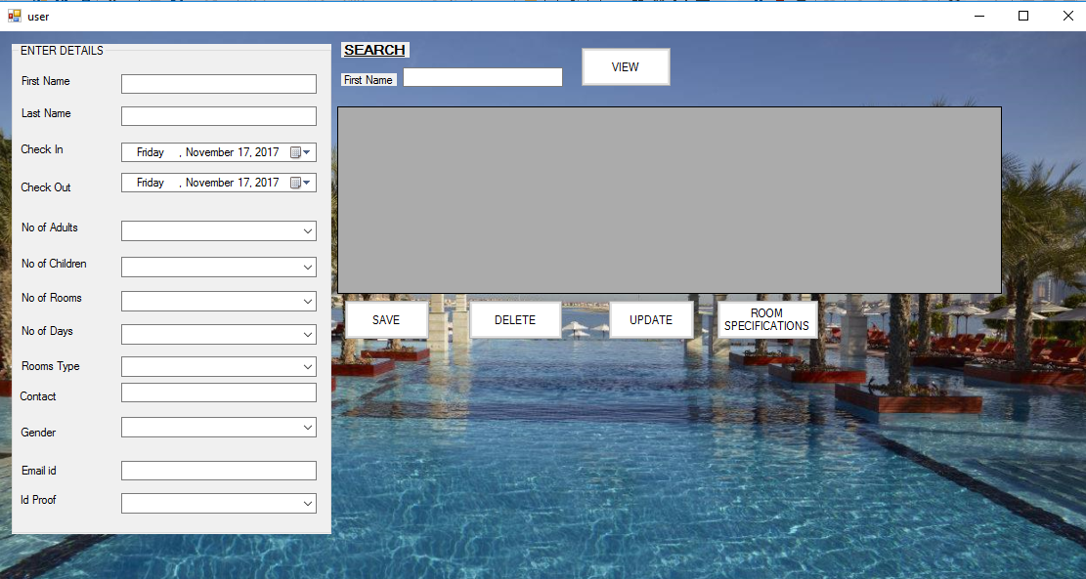

**Fig 4.5: USER LOGIN FORM**

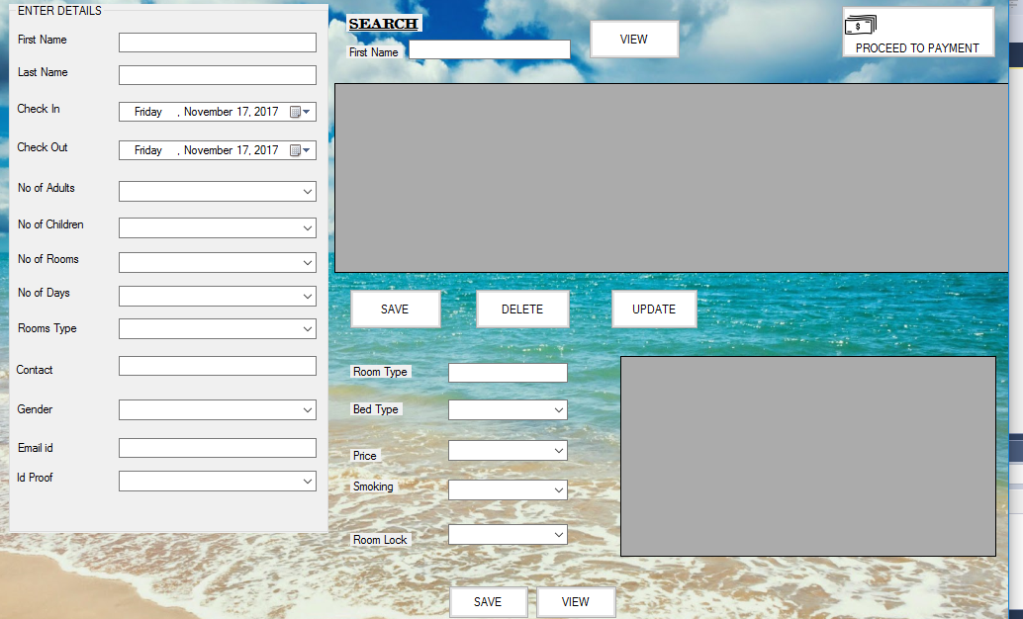

**Fig 4.6: AFTER USER LOGIN PERMISSION GIVEN TO EMPLOYEE**

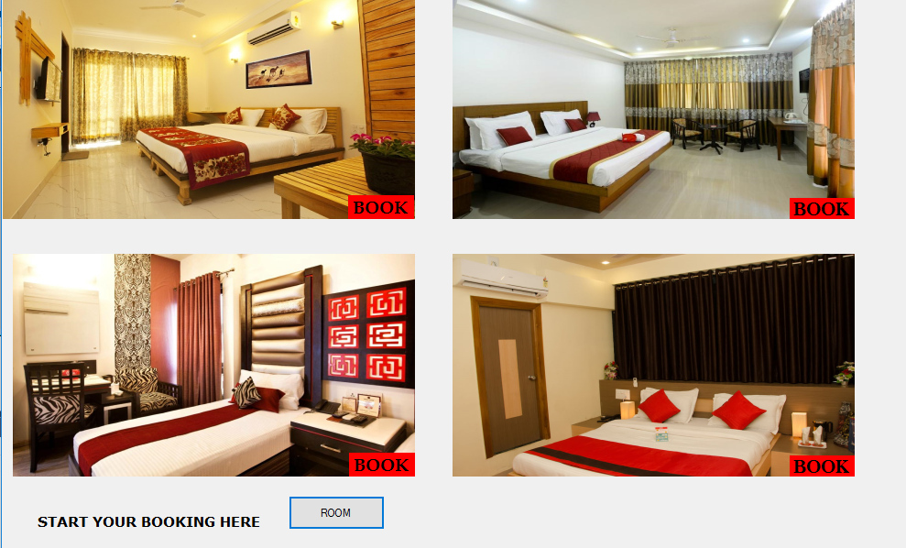

**Fig 4.7: ACCOMMODATION WINDOW**

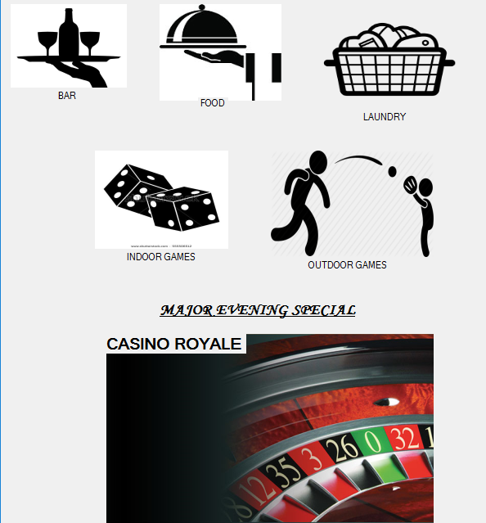

**Fig 4.8: SERVICES**